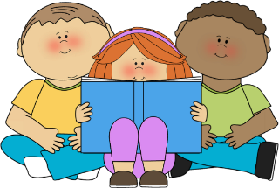

Year 3 – A few suggestions of books to read and enjoy
Make sure you give yourself time to read. When you start a new book, you need at least 20 minutes in a quiet place with no distractions so you can really begin to enjoy it.
Jeremy Strong
My Dad's Got an Alligator
My Granny's Great Escape
My Mum's Going to Explode
My Brother's Famous Bottom
My Brother's Famous Bottom Gets Pinched
For other brilliant Jeremy Strong books got to http://www.jeremystrong.co.uk/

Michael Morpurgo
Dear Olly
The Long Way Home
Gentle Giant
Dolphin Boy
Red Eyes at Night
The Marble Crusher
Snakes and Ladders
Conker

Jacqueline Wilson
Cliffhanger
Buried Alive
The Suitcase Kid
The Mum-Minder
The Story of Tracy Beaker
Best Friends
The Dare Game

Anne Fine
The Diary of a Killer Cat
Anneli the Art Hater
Bill's New Frock

David Walliams
Gangsta Granny
Mr. Stink
The World’s Worst Children
Don’t forget to keep reading picture books. They are certainly not just for little children. You could try:
Tuesday by David Weisner
How to live forever by Colin Thompson
Zoo by Anthony Browne
The Day the crayons quit by Drew Daywalt

Dick King-Smith
The Hodgeheg
Water Horse
The Sheep-Pig
George Speaks
The Fox Busters

Steve Cole
The Astrosaurs Series
http://www.stevecolebooks.co.uk/

Francesca Simon
Horrid Henry
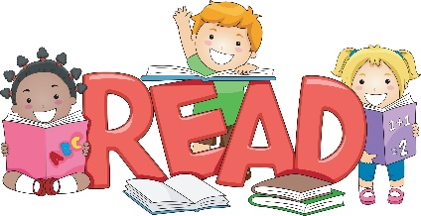
Gillian Cross
The Roman Beanfeast
The Demon Headmaster

Laurence Anholt
Cinderboy
Eco-Wolf

Other books and their authors:
Secret Friends by Elizabeth Laird
Deadulus and Icarus by Geraldine McCaughrean
Mrs Cockle's Cat by Philippa Pearce
The Dad Library by Dennis Whelehan
A Little Princess by Frances Hodgson Burnett
Greek Myths by Marcia Williams
Asterix by Albert Uderzo
Harry the poisonous centipede by Lynne Reid Banks
The True Story of the Three Little Pigs by Jon Scieszka
Daisy and the trouble with… by Kes Gray
The Worst Witch by Jill Murphy

