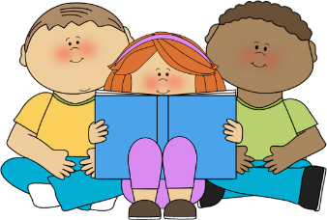

Year 4 – A few suggestions of books to read and enjoy
Make sure you give yourself time to read. When you start a new book, you need at least 20 minutes in a quiet place with no distractions so you can really begin to enjoy it.

Michael Morpurgo
e.g. Twist of Gold
Cool
Dear Olly
Toro Toro
Kaspar
The Dancing Bear
The Amazing Story of Adolphus Tips

J.K. Rowling Harry Potter and the Philosopher's Stone

Alex Shearer
e.g. Bootleg
Landlubbers
The Invisible Man's Socks
Sea Legs

Adam Blade - Beast Quest series

Jacqueline Wilson
e.g. The Suitcase Kid
The Bed and Breakfast Star
The Lottie Project
Double Act

Steve Cole- Astrosaurs series

Jeremy Strong
e.g The Hundred Mile an Hour Dog
Krazy Kow Saves the World
There's a Viking in my Bed

Anthony Horowitz
e.g. Granny
The Switch

How to train your Dragon by Cressida Cowell
Max and the Millions by Ross Montgomery
Desirable by Frank Cottrell Boyce
My Brother is a Superhero by David Solomons
There’s a Werewolf in my Tent by Pamela Butchart
The 13 - Storey Treehouse by Andy Griffiths
Frank Einstein and the Antimatter Motor by Jon Scieszka
Operation Gadgetman by Malorie Blackman

Roald Dahl
e.g. The Twits
Charlie and the Chocolate Factory
James and the Giant Peach

Fairy Tales by Terry Jones
The Hodgeheg by Dick King Smith
The Worst Witch by Jill Murphy
The Way to Sattin Shore by Philippa Pearce
The Firework Maker’s Daughter by Phillip Pullman
Billionaire Boy by David Walliams
Give Peas a Chance by Morris Gleitzman
Demolition Dad by Phil Earle
Cakes in Space by Philip Reeve and Sarah McIntyre
Anglo Saxon Boy by Tony Bradman



