The Waterside Times

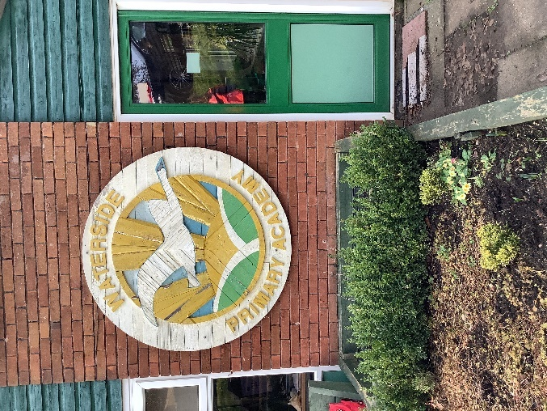
Welcome to the Waterside Times! Each half term we will bring you all the latest news and exciting events at Waterside Primary Academy. In this first edition you will find out more about our new headteacher Mrs Blackmore, our therapy dog Pickle and read our comic strips! We hope you enjoy reading!
Kamila, Etta, Fabrizio, Joachim, Daniel, Frank and Luke.
An amazing headteacher
Would you like to hear more about our new head teacher? We interviewed Mrs Blackmore to find out more about her first year at Waterside.
How did it feel when you first joined Waterside Primary Academy?
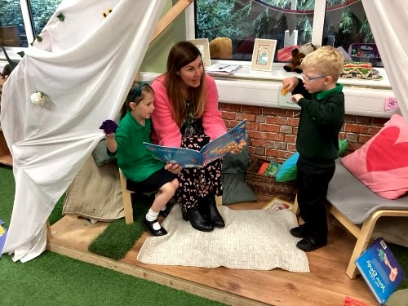
I feel really proud and excited about joining Waterside.
What was your favourite subject when you were at school?
My favourite subjects were English and reading.
What do you like about Waterside?
I absolutely love the amazing children and staff. It’s great to be part of such a special community.
What do you want to achieve in the future?
I’d really like to develop the outside area to make the area even better for the children. We’ve already started with the forest school and Chiltern Rangers, we are so lucky with all our space, we need to make the most of it!
Pickle the therapy dog helps people be calm and relaxed
Cathy and Pickle are a reading duo, where one of them is a trained therapy dog. They get loads of calls from schools to help them so we are very lucky to have them at Waterside. We interviewed Cathy to find out more!

What do you feel like when children see Pickle?
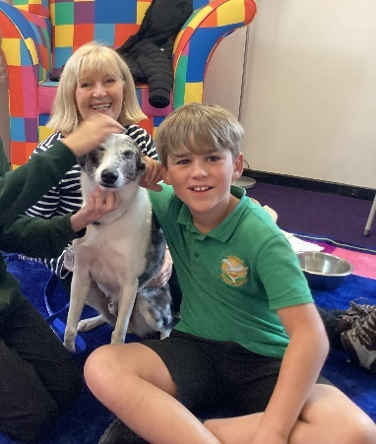
“I’m always happy when I see children with Pickle because they are calm and smiling and very gentle.”
How does Pickle help children and make them calm?
Pickle is a very calm dog and they really like meeting him. When they come to the reading sessions they don’t feel any pressure, it’s fun and they like reading to Pickle.”

What happens in the reading sessions?
“The children work in pairs to choose their books and sit on the beanbags in the library. One child holds the lead and then they swap and take turns. These sessions are from year 1 to year 6. At every session Pickle gets a treat and a paw shake.”
By Kamila (Year 6) and Daniel (Year 3)
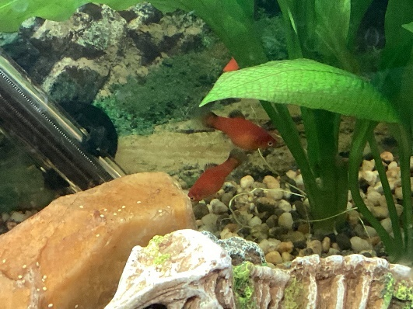
Fishy business!
In year 3 we are so excited as we have fish on the way! To prepare we added a background to the fish tank. We added a log and a fake skeleton of a dinosaur! My friend Harley helped Miss Butler, our teacher, to wash the gravel. Finally, we added a thermometer just to be sure that they are okay with the temperature of the water. We look forward to updating you when the fish arrive!
By Etta (Year 3)
The Epic Game!
Last Monday, the mighty Waterside played Chesham Bois at Rugby at home. Despite a brave effort, and great perseverance during the game we sadly lost 16 – 12. Star coach, Mr McHugh said, ‘The children were still persevering and despite the score they still kept trying.’ All children represented the school well, and clearly our school values were all on display. Harry told The Waterside Times, ‘I thought we played very well. The other team was prepared.’ High scorer Nicky, scored many tries during the match. Everyone that came to watch was thoroughly entertained. Why not join us pitch side to support Waterside at a future match?
By Kamila (Year 6), Daniel (Year 3) and Luke (Year 4)
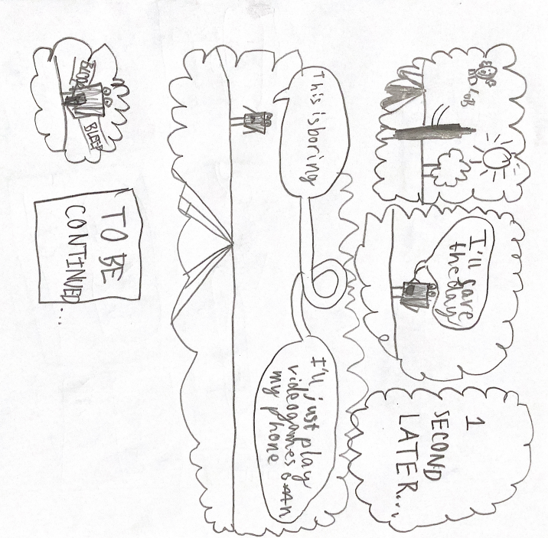
Comic 1 – By Daniel (Year 3)

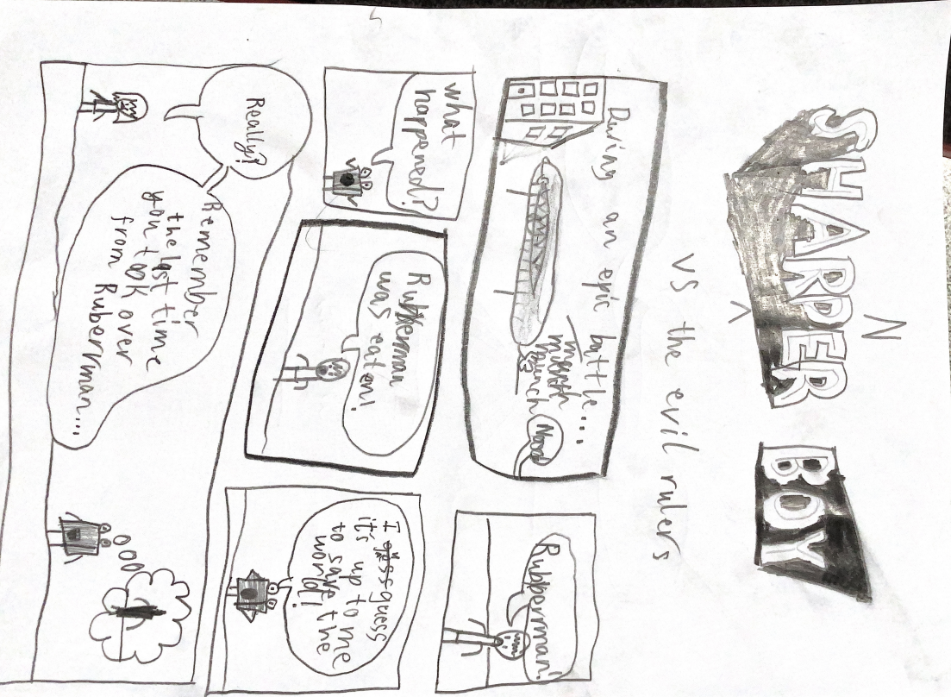

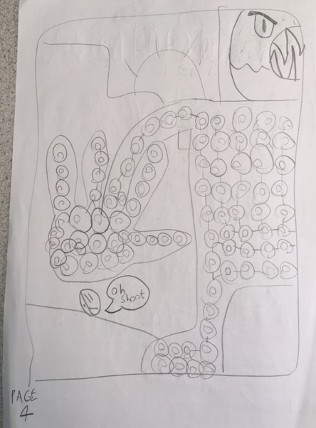
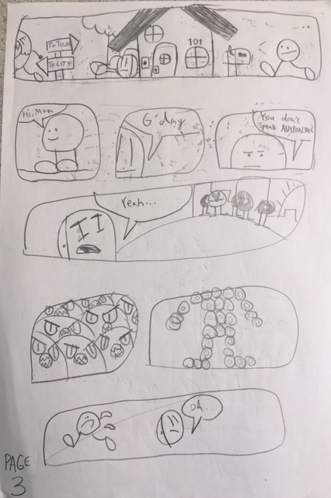
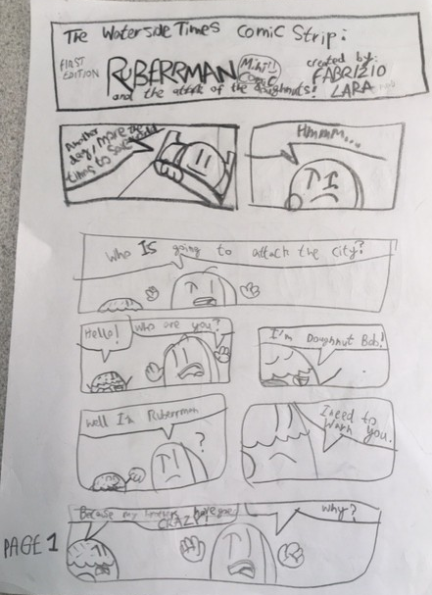
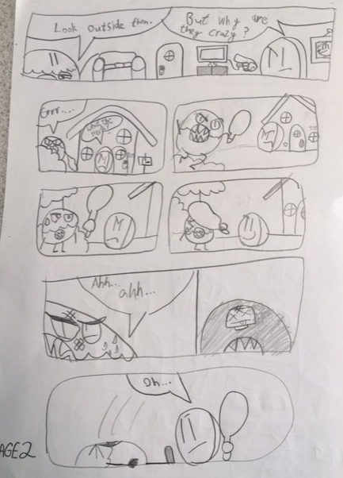
Comic 2 – By Fab (Year 5)


