The Waterside Times
Welcome to the second edition of the Waterside Times. This is the second draft so we hope you’re looking forward to reading the excellent newspaper report from our roving reporters.
In this edition you will find out about Gardening Club, the Rocksteady Concert and meeting our new staff members. Finally, the world book day golden ticket winners will be announced. Read on to find MORE! Thank you for reading our news-paper report.
Brilliant book costumes wow Waterside!
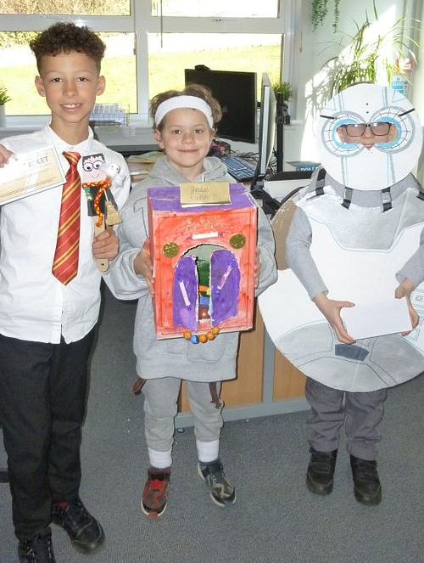
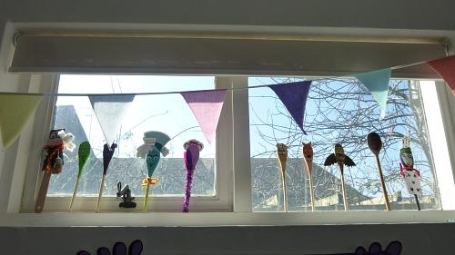
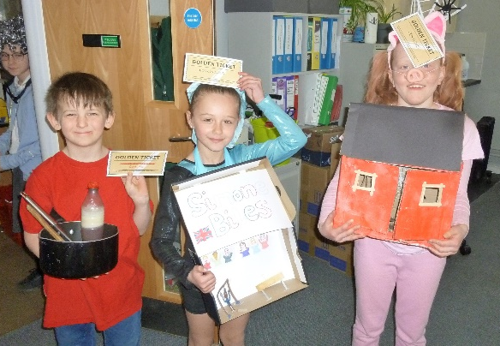
On the 6th of March the whole school celebrated World Book Day by dressing up as our favourite book characters. Lots of classes also joined in with the BBC Live Lesson and took part in the Big Live Read. Do you want to know who the lucky golden ticket winners were? Then read on…
Year 1  Tommy  Olivia  Eliza | Year 2  Isaac  Jojo  Dilan
Year 3  Rhys  Arthur  Woody | Year 4  Betsy  Grace  Luke
Year 5  Elsie  Ted | Year 6  Harry  Shamaira  Shaurya

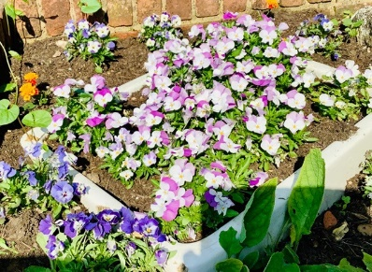
Green-fingered gardeners bring Waterside to life
During the Spring term Gardening club were busy weeding, before planting vegetables and flowers. You can now see their hard work in the beautiful flowers all around our Waterside School site. The group, supported by Mrs Nagle and Ms Gibbs, are suitably proud of their efforts.
“I liked it because we got to plant flowers and care for the school environment.” Khadija told our reporter.
“I feel really proud when I see all the colours from our flowers.” remarked Etta.
“I’m excited to eat our strawberries.” Arielle told us.
We look forward to seeing the vegetables when they are ready to harvest!
By Newspaper Club
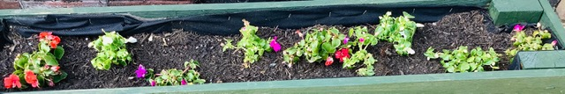

Would you like to meet Mrs Essery?

Welcome to our second interview with the newest members of Team Waterside. We will be talking to our lovely Mrs Essery. Would you like to see her amazing skills? Then read on to find out more!
What was your favourite subject when you were at school?
I liked lots of different subjects but my favourite subject was history.
What other jobs did you have before you started working in a school?
I did lots of things prior to working in a school. I was a makeup artist, then an area manager for a cosmetics company, finally a bodyguard. As a bodyguard, I travelled to lots of different places.
What is your favourite food?
Anyone who’s in the dining room will know – I like jacket potato with cheese and beans.
What do you like about working at Waterside?
I like that in my job, I can teach every class every week. So each week, I get to see and get to know all the children in the school. I also get to teach different subjects, so it’s never boring!

Rock and Roll!
Waterside enjoyed an exceptional live music concert from our Rocksteady Bands last half term. It was amusing, fabulous and lots of fun!
“I was a bit nervous, but it was really fun to perform.” shared Etta (Year 3).
“Even though I wasn’t performing, I could see what the children had been learning. I thought it was really good; the guitars, the drums and the singers.” Arielle (Year 3) told our reporters.
Rocksteady is where you can learn an instrument as part of a band, alongside other children from different year groups. You can improve your confidence and make new friends.
If you would like to join a Rocksteady Band, then speak to our Band Leader for more details!



Perilous Puzzles!
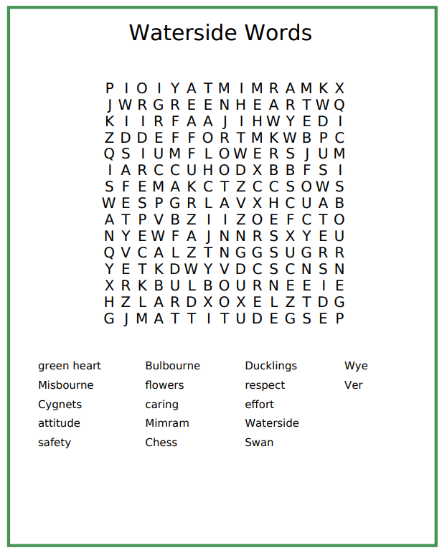
Can you find all our wonderful Waterside words?

