Year 4 Homework Tasks Spring Half Term 1
Homework will be due in every Tuesday. You can present your homework in your folder in whichever way you choose (photographs, making things, drawings, writing etc.) Remember to present your work neatly and include it in your orange homework book, or send it via Class Dojo. We have dated the homework we would like you to complete on the top of each box for that week and it will be due in the Tuesday after the date specified.
- Set: 9th January  Due: 13th January | - Set: 16th January  Due: 20th January | - Set: 23rd January  Due: 27th January
In Literacy, we are working on using detailed description to bring a story alive for the reader. We will be describing the arctic setting of our new book ‘The Last Bear’.    Go outside in the cold; what does it feel like? What can you see? Can you describe it with a simile? Bring your ideas to school to add to our writing. | In Reading, we are looking at folk tales and story-telling.    Talk to your adult about stories that their family told them when they were little. Can they pass these stories on to you?  Why not record yourself orally sharing a story with a sibling or family member. | In Art, we are learning about the work of Paul Cézanne.  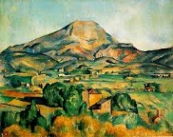  Share something about his works or his life in any way you like. Could you write a fact file? Paint a picture in his style? The choice is yours!
- Set: 30th January  Due: 3rd February | - Set: 6th February  Due: 10th February | - Set: 13th February  Due: After half term holidays
Next week in Geography, we will be applying our River knowledge to our own River Chess.  On plain paper or in your homework book, draw what you think a river looks like. Include things you might see at the River Chess. Then, label the parts of the river. You might want to go on a walk there and sketch what you see.  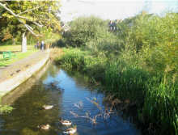 | 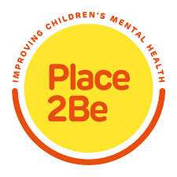  Next week is Place 2 Be’s Children’s Mental Health Week. The theme this year is ‘This is my place’ and is all about belonging.  Where do you feel like you belong? With your family? At school? At Scouts?  Write a list of the places where you feel you belong. Why not add illustrations or explain why these places are so important to you. | Next half term we will be writing letters to the government to ask them to help us protect the environment.  Task 1: Who in government should we be writing to? Find out who oversees environmental policy both locally and nationally.  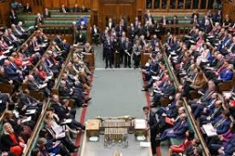  Task 2: Start considering why protecting the environment is important, and what we have learned about small changes that we can make. Make a mind map of your ideas ready for our work after the holidays.

