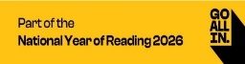
National Year of Reading 2026 Challenge
This at home reading challenge has been designed to be completed from January 2026-December 2026 in celebration of us supporting the ‘National Year of Reading 2026’ initiative. Once you have completed your first 5 sections please bring to Mrs Blackmore and once your final 5 sections are complete then please bring to Mrs Orchard.
Challenge 1  Read a recipe from a magazine, book or online. Can you follow the recipe to create something amazing or maybe even put your own spin on it.  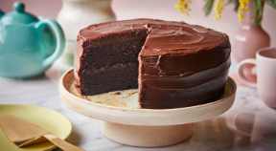 | Challenge 2  Books don’t just have to be in paper form. Try an audio book and see where your imagination takes you.  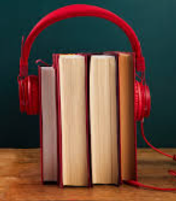 | Challenge 3  Read a genre of book you have never tried before and create a book review about it. There are so many books out there just waiting to be discovered………..  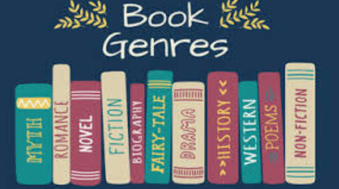 | Challenge 4  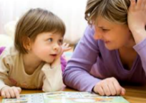  Share a book with as many different people as you know and ask them what their favourite book is and why. Tell them what your favourite book is and why they should read it. You could write them a than you card afterwards | Challenge 5  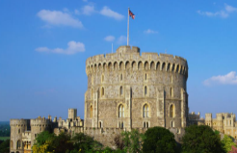  Read online or in a book about a local landmark or place you haven’t visited before. If you are able to, go and visit it to see if the facts you read were correct. | Challenge 6  Read a book with the title/author/illustrator for each letter of the alphabet. Can you read a book linked to all 26 letters?  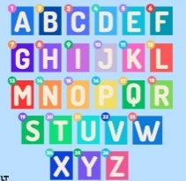 | Well done, you have completed your first 6 sections. Please come and show Mrs Blackmore.  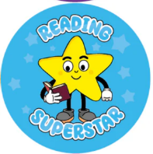
Challenge 7  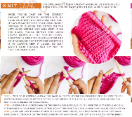  Read instructions on how to build/make something or even read instructions for a new board game. This could be anything from knitting to flat pack furniture. | Challenge 8  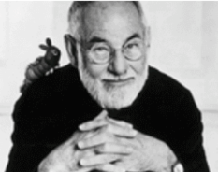  Research an author of your choice and read at least THREE of their books. Create your own book recommendation of your favourite one. | Challenge 9  Create or write your own story for someone else to read and enjoy.  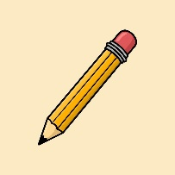 | Challenge 10  On our school website under Curriculum- We are Readers’ we have a suggested book list for each year group. How many can you read from this list?  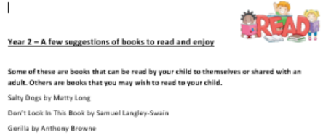 | Challenge 11  Reading doesn’t always have to be In the form of a book. Try and find text in as many different places as possible such as information in a museum, road signs or a menu when you are doing for lunch.  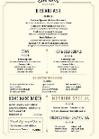 | Challenge 12  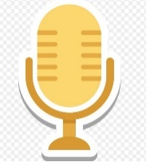  Create a video/audio recording of you telling a known or made up story. | What an incredible achievement! You have now completed all 12 reading challenges. Please come and show Mrs Orchard.  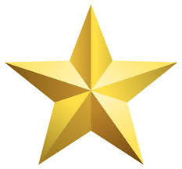
Please use the following link for some fantastic free resources and ideas in how you can support your child with reading at home.
https://wordsforlife.org.uk/parent-support/

