World Book YAY!
Today we celebrated World Book Day at Waterside. On World Book Day we take part in loads of fun activities all about reading. It is one of the best days of the year.
Mrs Orchard worked hard to plan this perfect event for us all to enjoy.
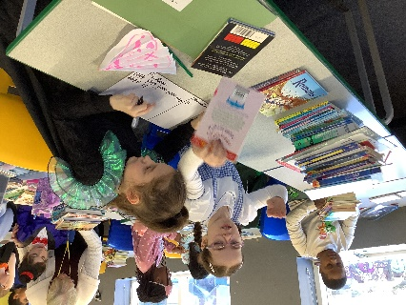
There were golden tickets handed out to children who made the best of each event. The events included: book in a jar, make a mini book and character costume. They were rewarded with a choice of an exciting, brand new book, with a diverse amount of books and genres to choose from. It was an amazing day full of fun and activities. “I hope my book token gets published!” Viaan stated. “It was a really good day.” Fabrizio replied.
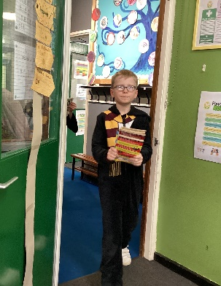
Here are some of our favourite things about World Book Day:
“I loved World Book Day because when you’re reading you can slowly drift into your own world,” Jaylan from Year 4 told our reporters.
“My favourite part was the live lessons and lots of other fun activities, like making bookmarks and entering the book token competition,” said Esmé in Year 3.
“I liked the Live Lesson too because it was really fun!” explained Arthur from Year 4.
“It was really good going outside and reading a book in the sunshine,” recalled Sofia in Year 3.
Everyone put lots of effort in to their costumes, and we saw some brilliant book characters across the school. We saw Veruca Salt, Willy Wonka, Dog Man, Pablo, Harry Potter, Little Red Riding Hood and Elsa. Even the teachers joined in and got dressed up!
Another favourite moment of the day was when the PTA kindly gave us all chocolate milkshake and a bourbon biscuit. It was lovely to sit and relax with this delicious treat.
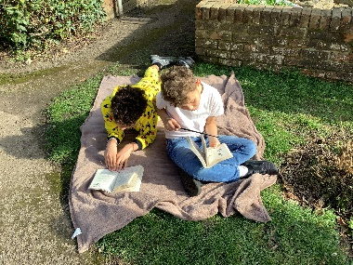
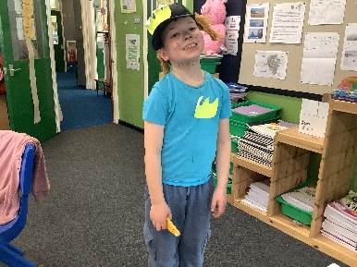
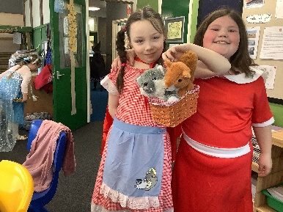
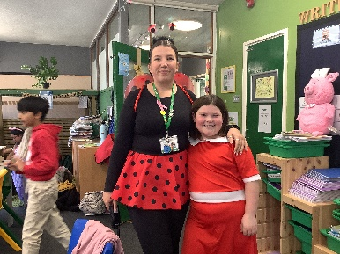
Finally, Mrs Orchard also organised a book swap for after school, where we picked books. We really enjoyed the epic book swap! Thank you so much for all your kind donations which made this fabulous event possible.

