07/07/26
Dear Parents,
Your children have had their transition day on Tuesday 7th July and we hope they thoroughly enjoyed meeting their new teacher and support staff. Schools are facing increasing financial pressures and as a result we will require children in KS2 to bring their own pencil case and equipment for the next academic year in September. This also creates a sense of responsibility to look after their own belongings and helps prepare children for their transition to Secondary school.
The following is a list of things we feel your child will need in September:-
Named pencil case which is clear and plain | 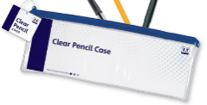
Two HB pencils | 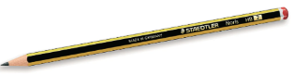
Two handwriting pens (Blue ink- No biros) Children will start getting pen licences in Y3. | 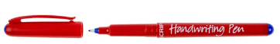
A purple biro rollerball pen | 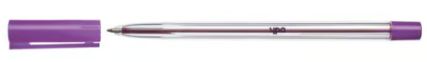
Rubber | 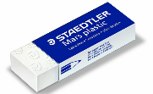
30cm ruler (Plus an additional smaller ruler to fit inside the pencil case) | 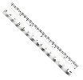
A set of colouring pencils (Maximum 12) | 
2 black Whiteboard pens (Non-permanent/dry erase markers) | 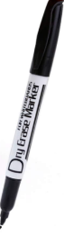
A small pair of round ended scissors | 
Glue stick | 

We really appreciate your support with this but if you have any questions then please do not hesitate to contact us.
Many thanks
The SLT team

